H.T No
Regulations:
A20

Sreenidhi Institute of Science and Technology
(An Autonomous Institution)
Code No: 8K201 Date: 18-Feb-2025 (FN)

B.Tech I-Year II- Semester External Examination, February-2025 (Supplementary)
ENGINEERING MECHANICS FOR CIVIL ENGINEERING (CIVIL)

Time: 3 Hours Max.Marks:70

Note: a) No additional answer sheets will be provided.
b) All sub-parts of a question must be answered at one place only, otherwise it will not be valued.
c) Missing data can be assumed suitably.
Bloom's Cognitive Levels of Learning (BCLL)

Remember | L1 | Apply | L3 | Evaluate | L5
Understand | L2 | Analyze | L4 | Create | L6

Part - A Max.Marks:20

Answer all QUESTIONS.

 |  | BCLL | CO(s) | Marks
1 | Define the term free body diagram and state the importance of drawing such diagram. | L2 | CO1 | [2M]
2 | Discuss the laws of Static and Dynamic Friction. | L5 | CO2 | [2M]
3 | Define centroid and centre of gravity of an area. | L1 | CO3 | [2M]
4 | Define the principle of virtual work and state it’s application. | L4 | CO4 | [2M]
5 | Write a short note on curvilinear translation. | L3 | CO5 | [2M]
6 | Explain the D’Alembert’s Principle. | L2 | CO6 | [2M]
7 | Define Method of joints & section. | L1 | CO1 | [2M]
8 | State parallel axis theorem as applied to mass moment of inertia. | L3 | CO3 | [2M]
9 | State work-energy principle for Linear motion of a rigid body. | L4 | CO6 | [2M]
10 | What does the second theorem of pappus indicate? | L3 | CO4 | [2M]

Part – B Max.Marks:50
ANSWER ANY FIVE QUESTIONS. EACH QUESTION CARRIES 10 MARKS.

 |  |  | BCLL | CO(s) | Marks
11. | a) | Write the moment of force and its application? | L2 | CO1 | [5M]
 | b) | The resultant of two-forces, one of which is three times the other force is 300 N. When the direction of small force is reversed, the resultant is 200 N. Determine the 2-forces and the angle between them. | L4 | CO1 | [5M]
12. |  | For the blocks shown in Fig. 1 Find the value of pull ‘P’. The coefficient of friction between blocks is 0.24 and the same between block and floor is 0.3.  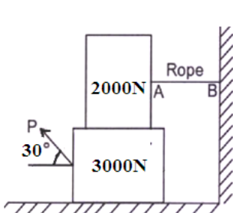 | L4 | CO2 | [10M]
13. | a) | State and define Pappus theorem in detail? | L3 | CO3 | [5M]
 | b) | What is the least value of ‘P’ to cause motion to impend for the system of the forces shown in figure. Assume co-efficient of friction to the 0.2  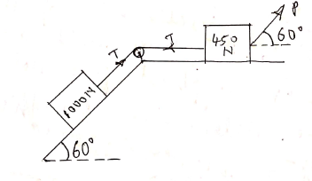 | L4 | CO3 | [5M]
14. |  | A simply supported beam at the ends of 5m span carries a load of 15KN at a distance of 2m from one end. Determine the end reaction using the principle of virtual work.  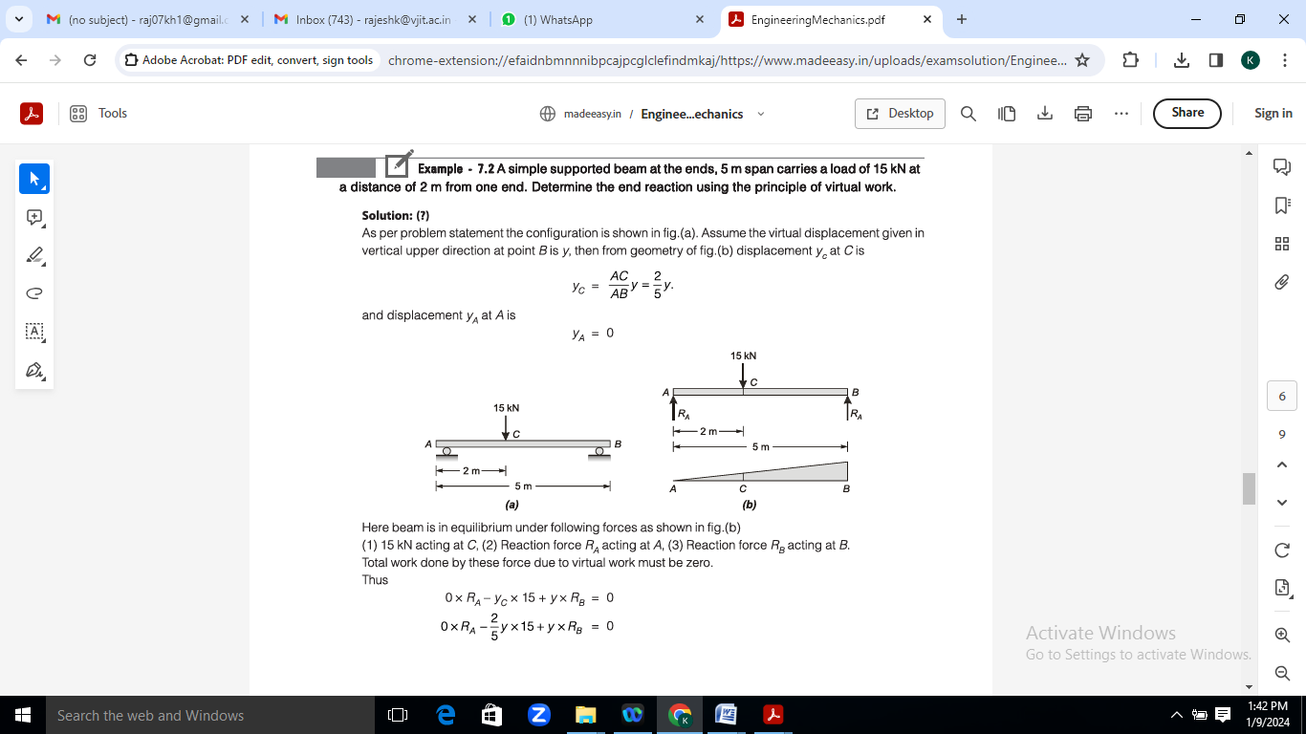 | L1 | CO4 | [10M]
15. | a) | An aeroplane is flying horizontally at a height of 30cm a bomb is released from the aeroplane when the speed is 600 km/hr. determine the time required for the bomb to reach the ground and the horizontal distance travelled by the bomb during flight. | L3 | CO5 | [5M]
 | b) | A bullet moving at the rate of 250 m/sec is fired into a log of wood. The bullet penetrates to a depth of 40cm if the bullet moving with the same. Velocity is fired into a similar piece of wood of 20cm thickness with what velocity would it emerge. Takes the resistance to be uniform in both the cases. | L3 | CO5 | [5M]
16. | a) | A projectile is fired with a initial velocity of 250 m/s at a target located at a horizontal distance of 4km & vertical distance of 700 m above the gun. Determine the value of firing angle to hit the target neglect the air resistance. | L5 | CO6 | [5M]
 | b) | Define elastic impact. Explain the types of impacts. | L2 | CO6 | [5M]
17. | a) | State & prove the Lami’s theorem. | L5 | CO1 | [4M]
 | b) | List the steps followed in the analysis of truss by method of joints. | L2 | CO2 | [3M]
 | c) | When does a given system of parallel forces can be reduced to couple? Discuss. | L3 | CO3 | [3M]
18. | a) | What is product of inertia illustrate with example | L1 | CO4 | [4M]
 | b) | Explain the curvilinear translation. | L2 | CO5 | [3M]
 | c) | State the law of conservation of momentum. | L3 | CO6 | [3M]

-- 00 -- 00 –

